Kimmel Aldrich T. Delector Activity
Total sales for each product
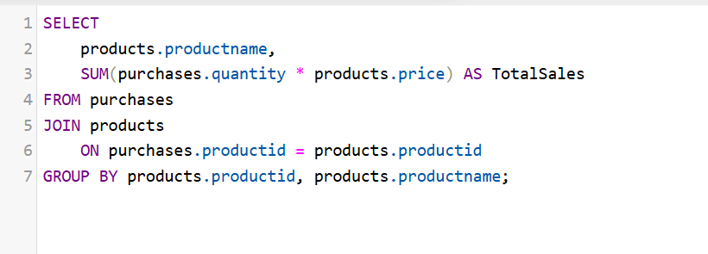

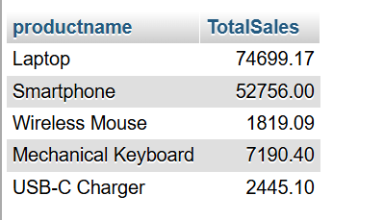
Total Sales

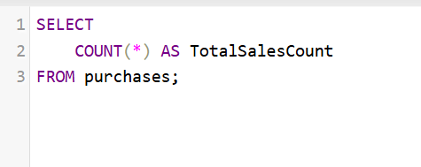
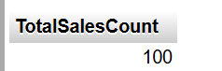

Total sales of a specific product (Laptop)

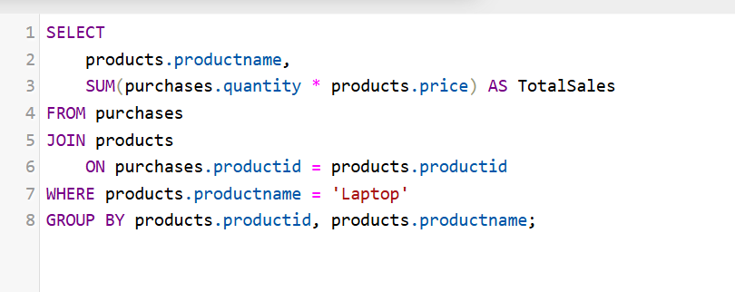
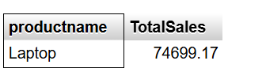
Total quantity sold per product
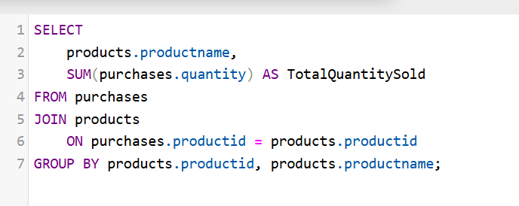
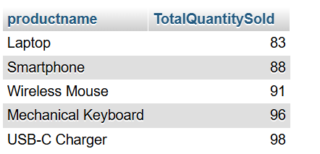

1. Add product, customer, sales
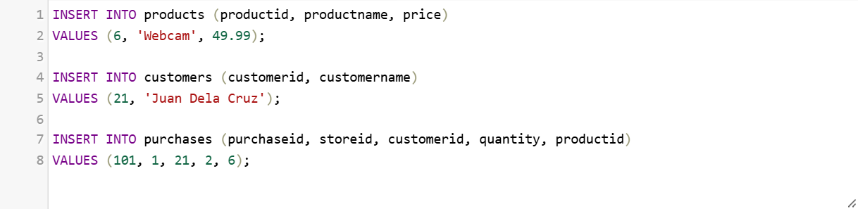
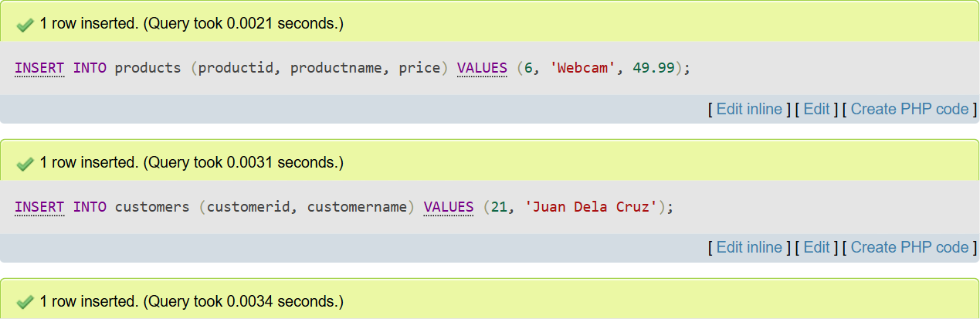
Checking the result
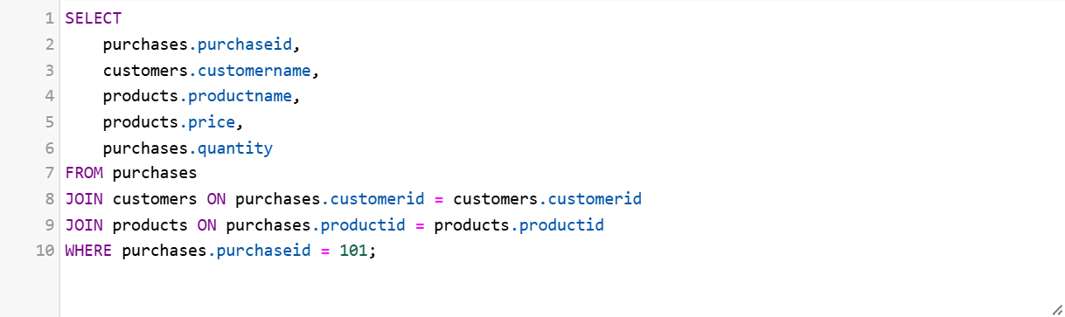
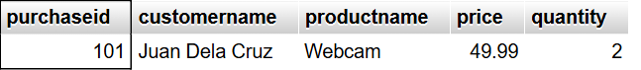

2. Update product and customer
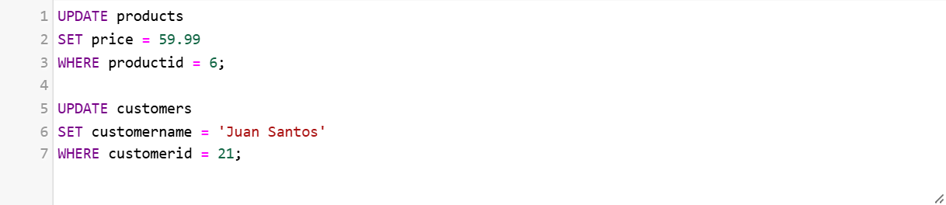
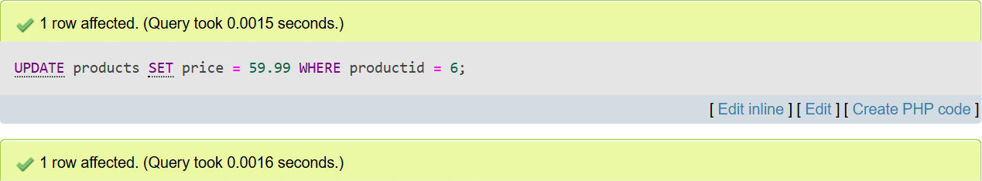
Checking the result
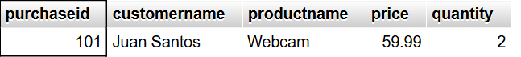

3. Delete product and customer
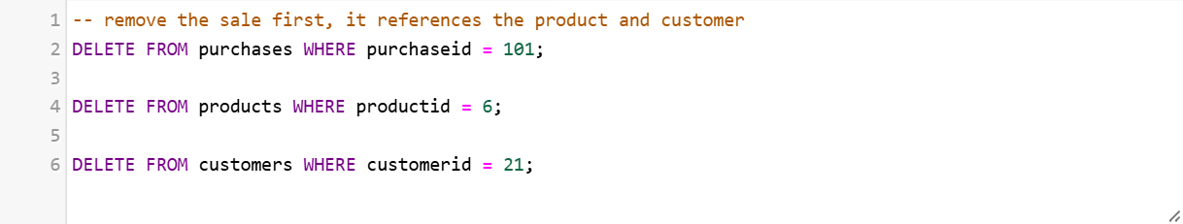
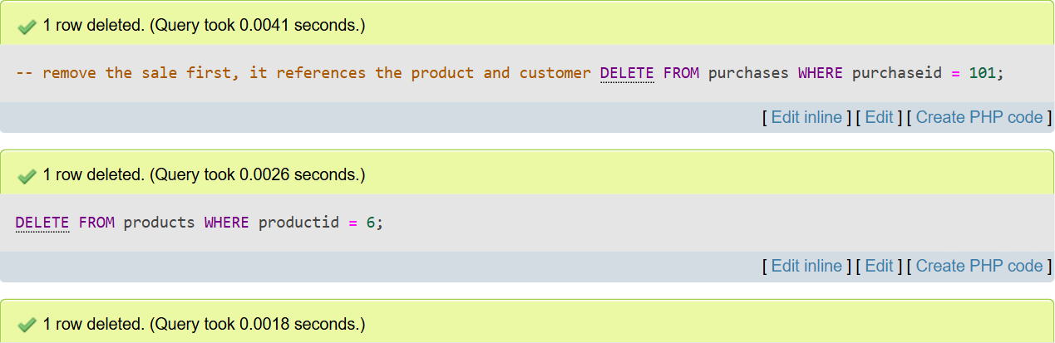
Checking the result

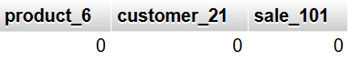

4. Query customers
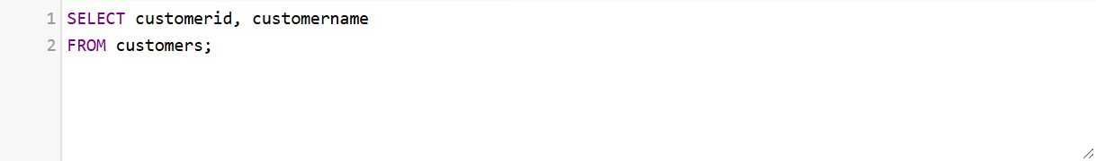
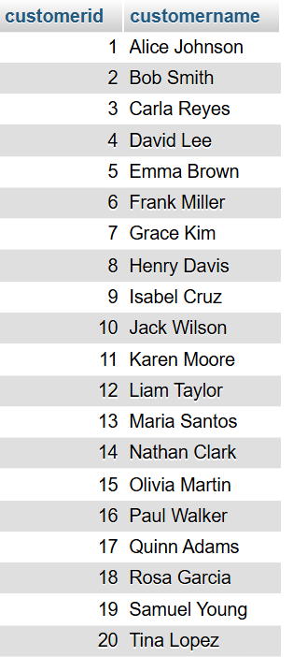

5. Query sales
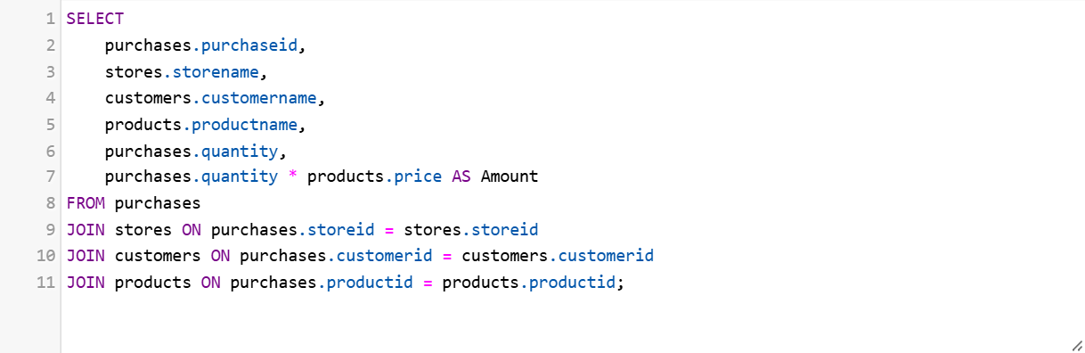
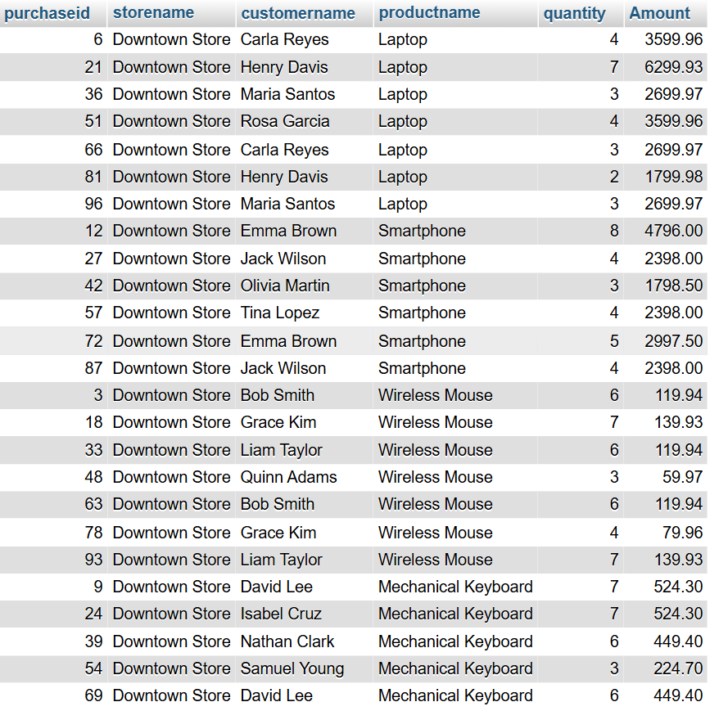

6. Query products
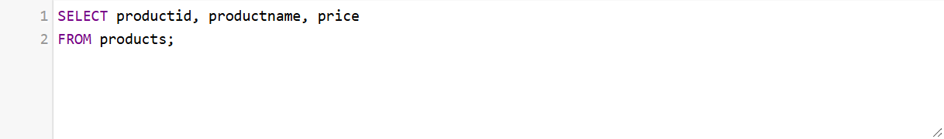
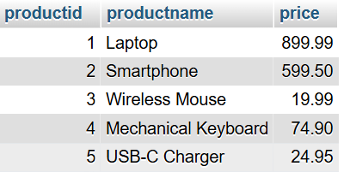

7. Query customers purchases
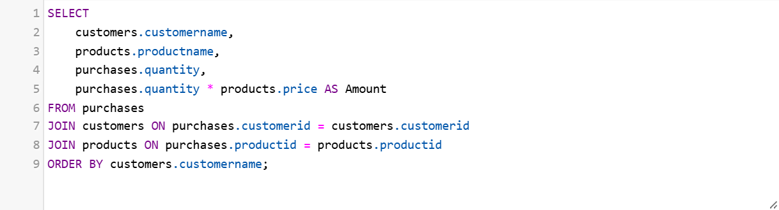
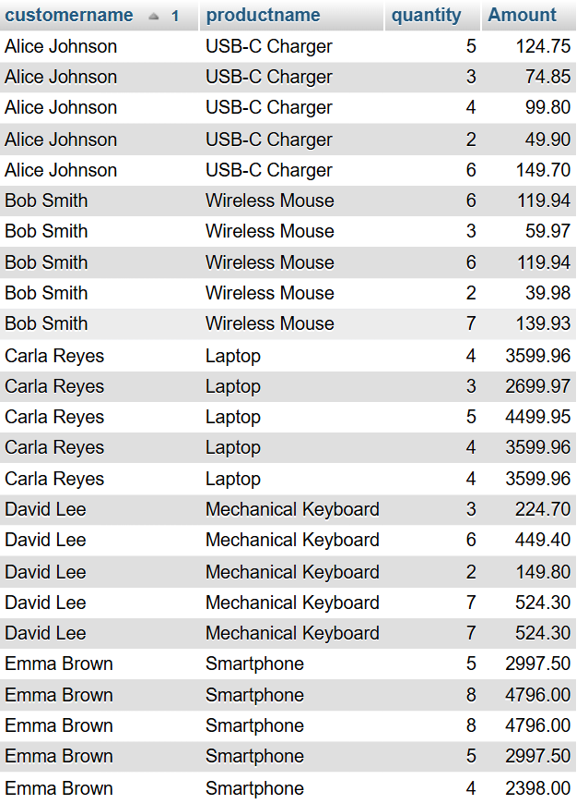

8. Query customers total purchase amount
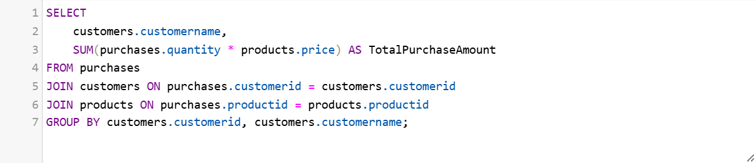
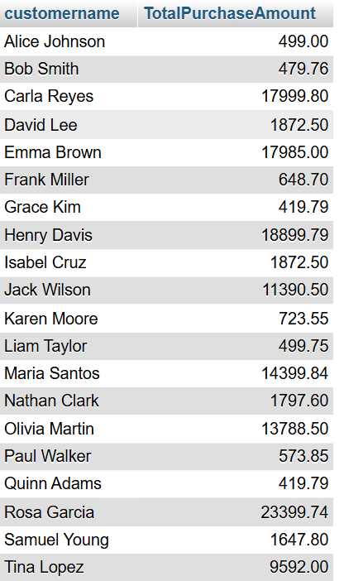

9. Query Average sales

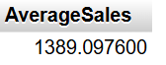

10. Query top customers based on sales
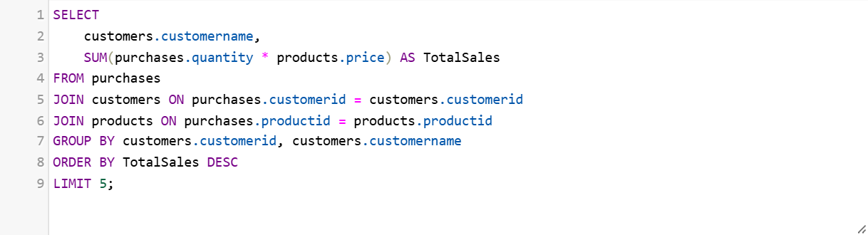
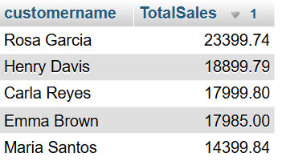

11. Query products
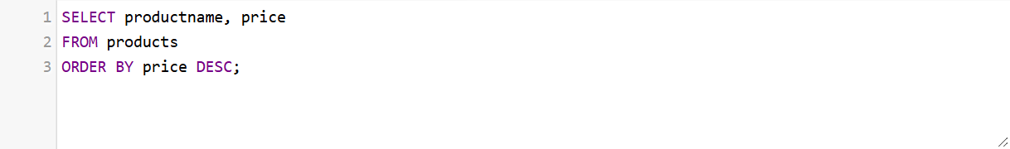
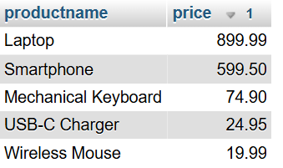

12. Query product sales (Specific product)
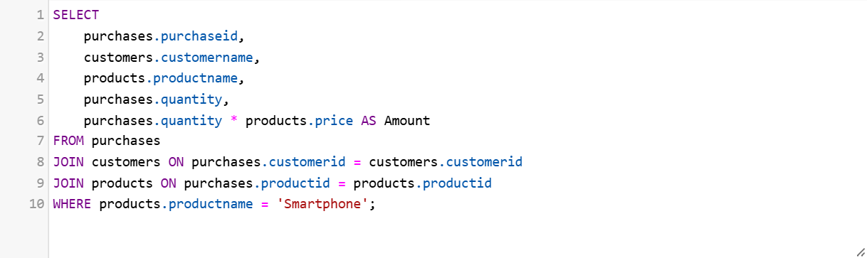
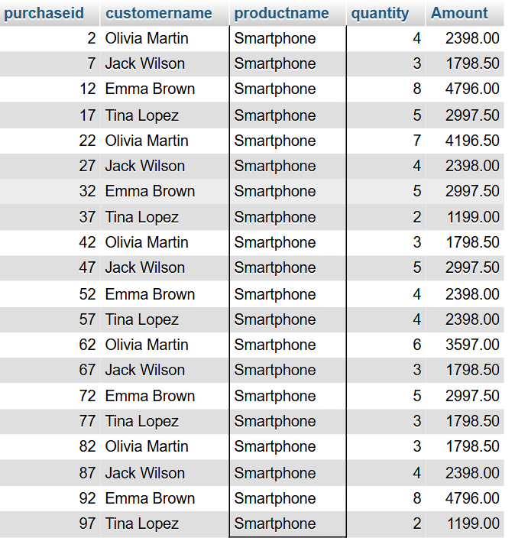

13. Query the total sales of specific product
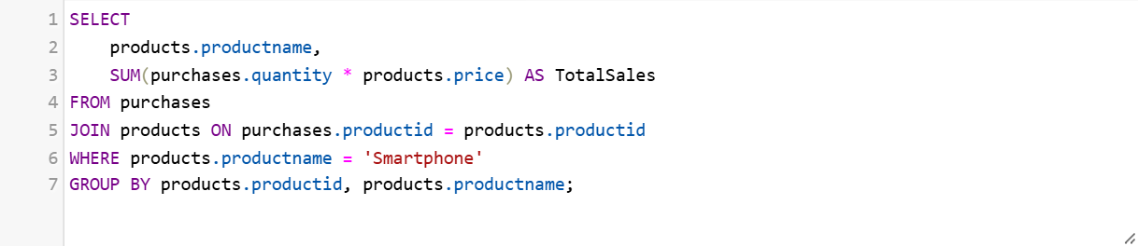
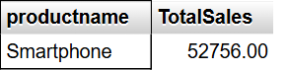

14. Query the average sales of specific product
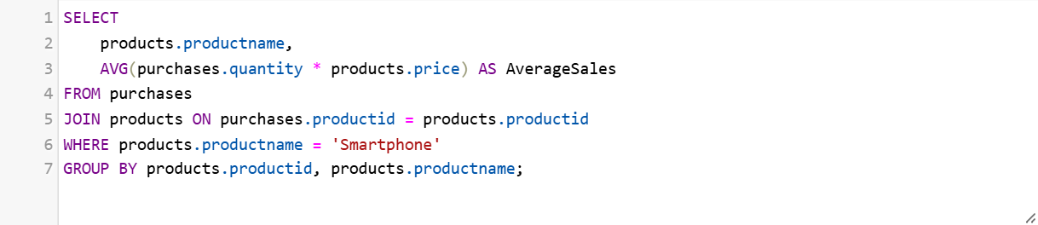
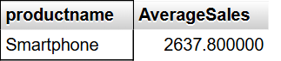

15. Query the top 5 products based on sales


